week5_2_ Microservices with API gateway
01_Creating Microservics for account andl oan
Account
AccountController.java
package com.cognizant.account.controller;

import org.springframework.web.bind.annotation.*;

import java.util.Map;

@RestController
@RequestMapping("/accounts")
public class AccountController {

@GetMapping("/{number}")
public Map<String, Object> getAccount(@PathVariable String number) {
return Map.of(
"number", number,
"type", "savings",
"balance", 234343
);
}
}
AccountApplication.java
package com.cognizant.account;

import org.springframework.boot.SpringApplication;
import org.springframework.boot.autoconfigure.SpringBootApplication;

@SpringBootApplication
public class AccountApplication {
public static void main(String[] args) {
SpringApplication.run(AccountApplication.class, args);
}
}
application.properties
spring.application.name=account
AccountApplicationTests.java
package com.cognizant.account;

import org.junit.jupiter.api.Test;
import org.springframework.boot.test.context.SpringBootTest;

@SpringBootTest
class AccountApplicationTests {

@Test
void contextLoads() {
}

}
Loan
LoanController.java
package com.cognizant.loan.controller;

import org.springframework.web.bind.annotation.*;

import java.util.Map;

@RestController
@RequestMapping("/loans")
public class LoanController {

@GetMapping("/{number}")
public Map<String, Object> getLoan(@PathVariable String number) {
return Map.of(
"number", number,
"type", "car",
"loan", 400000,
"emi", 3258,
"tenure", 18
);
}
}
LoanApplication.java
package com.cognizant.loan;

import org.springframework.boot.SpringApplication;
import org.springframework.boot.autoconfigure.SpringBootApplication;

@SpringBootApplication
public class LoanApplication {
public static void main(String[] args) {
SpringApplication.run(LoanApplication.class, args);
}
}
application.properties
spring.application.name=loan
server.port=8081
LoanApplicationTests.java
package com.cognizant.loan;

import org.junit.jupiter.api.Test;
import org.springframework.boot.test.context.SpringBootTest;
@SpringBootTest
class LoanApplicationTests {
@Test
void contextLoads() {
}
}
OUTPUT
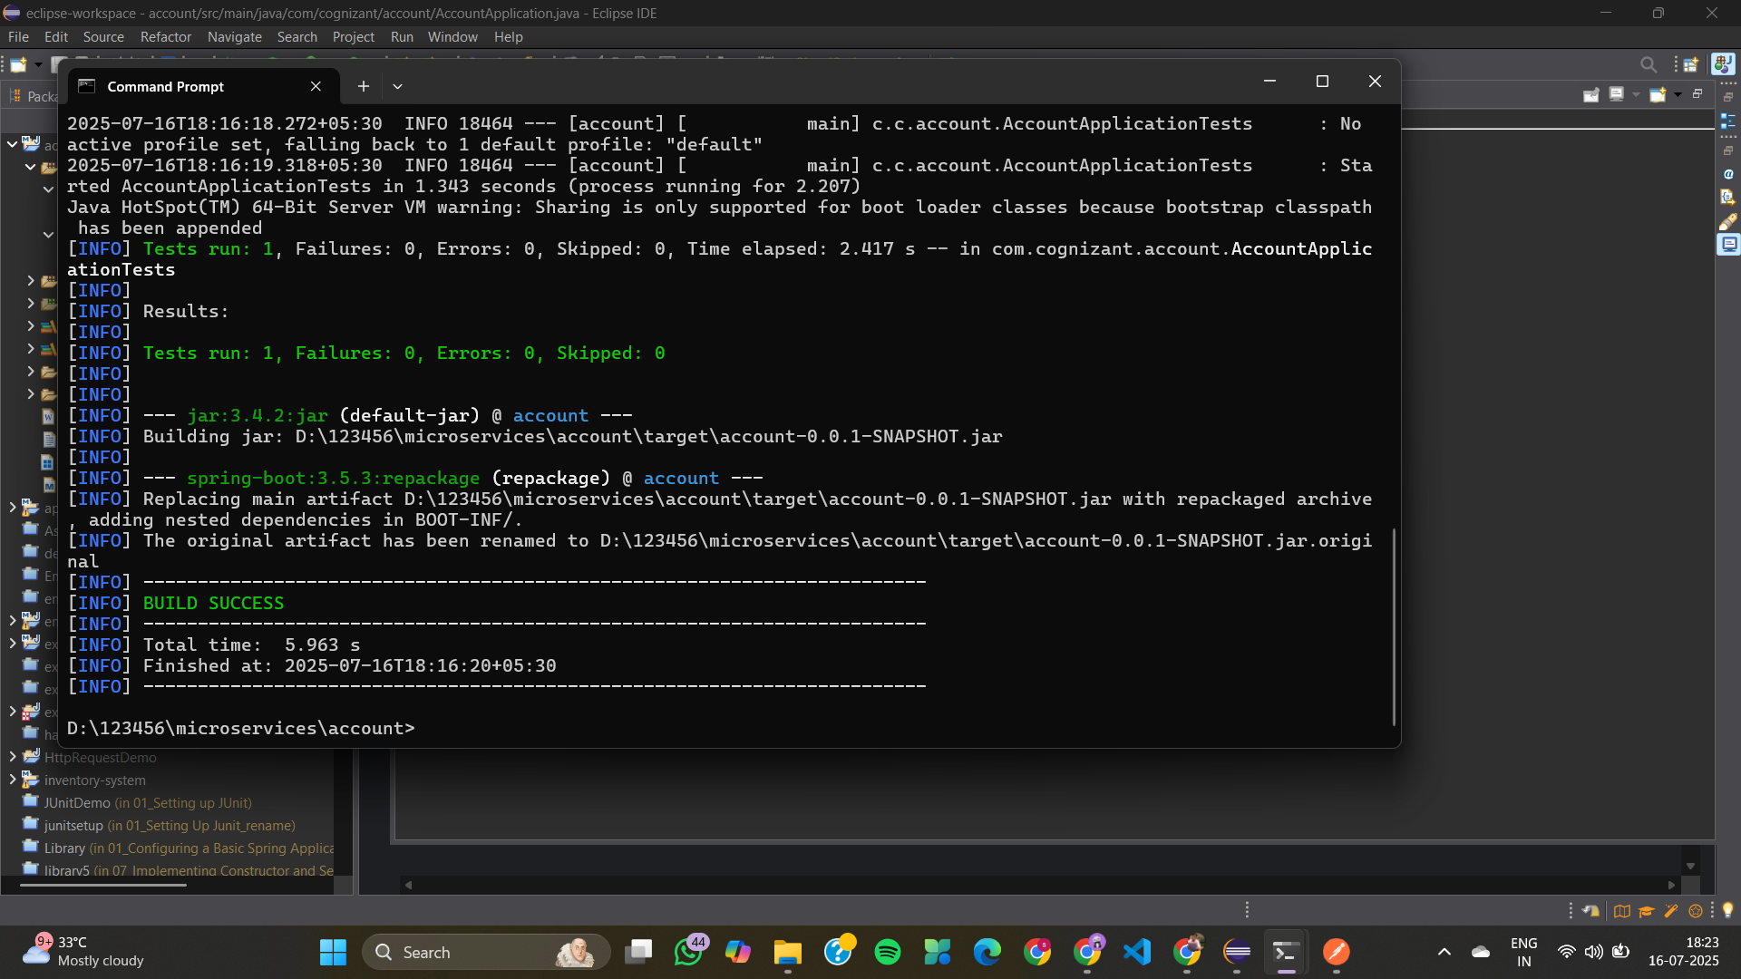
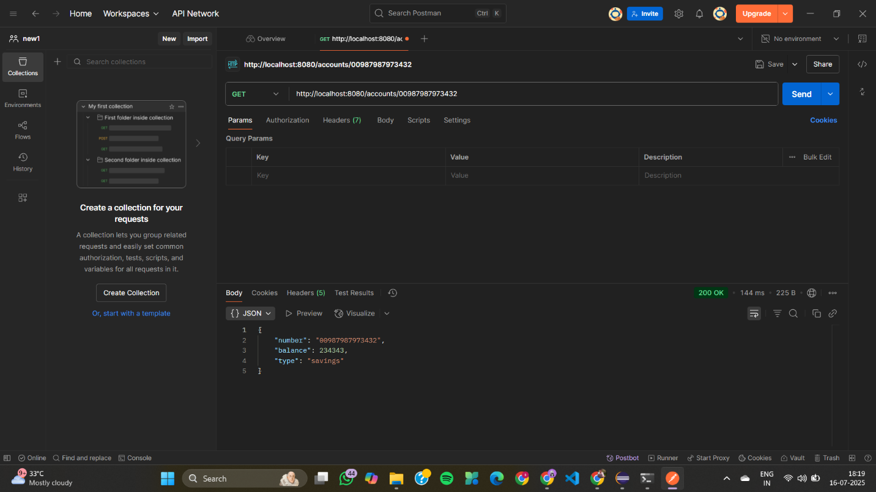
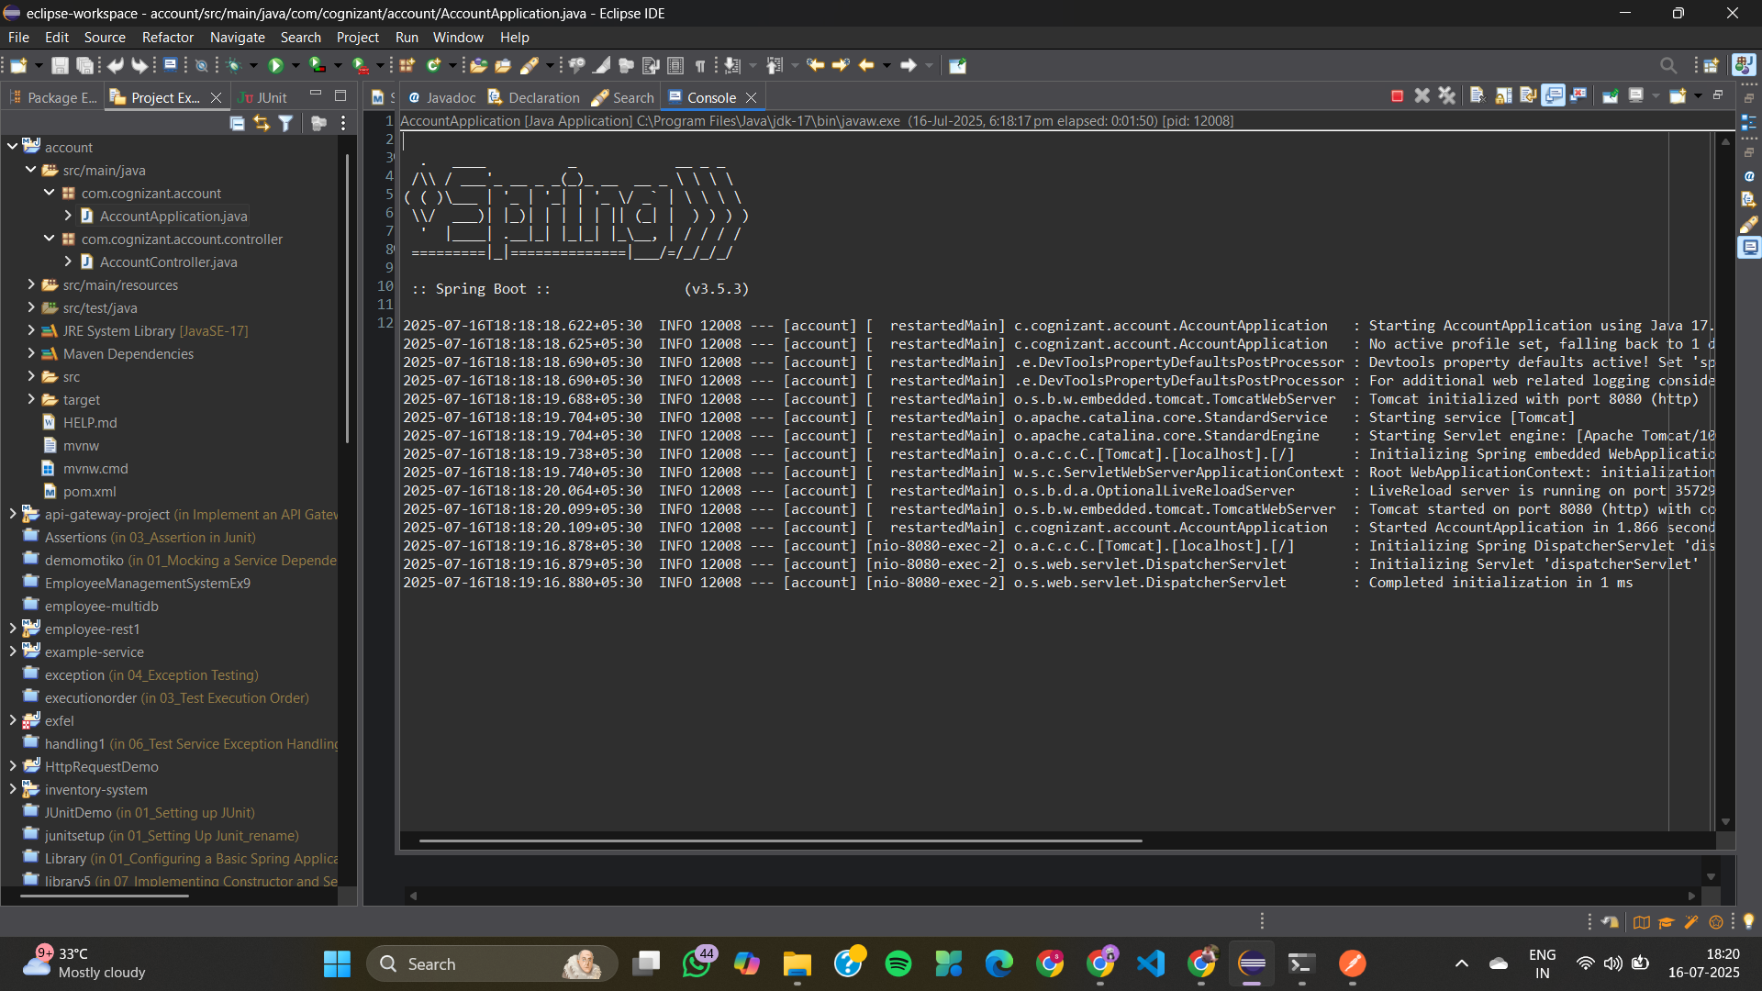
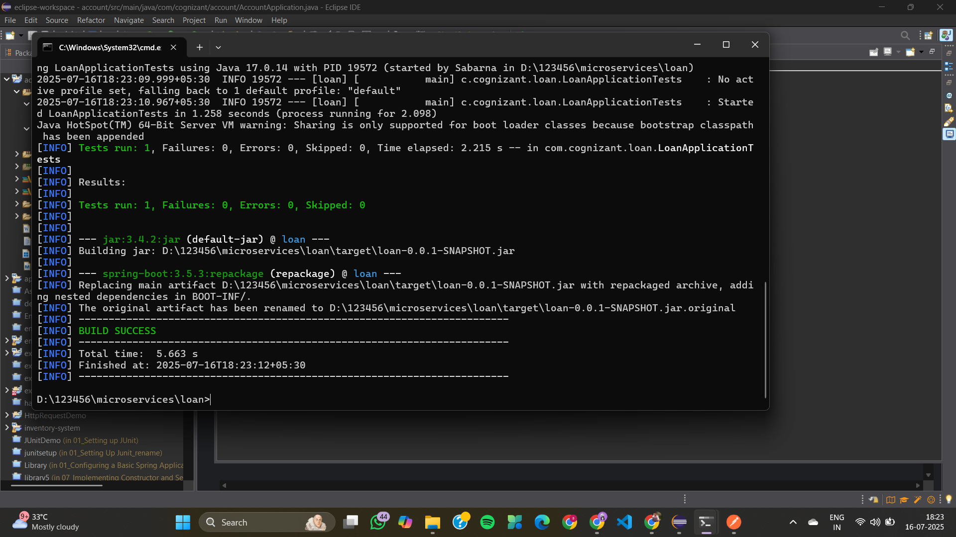
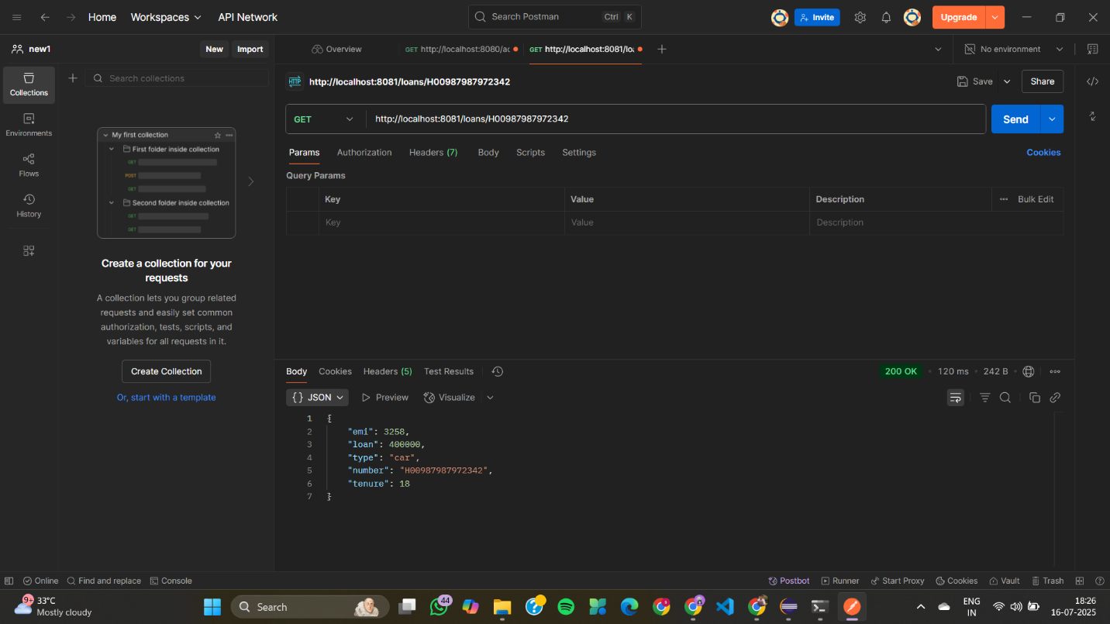
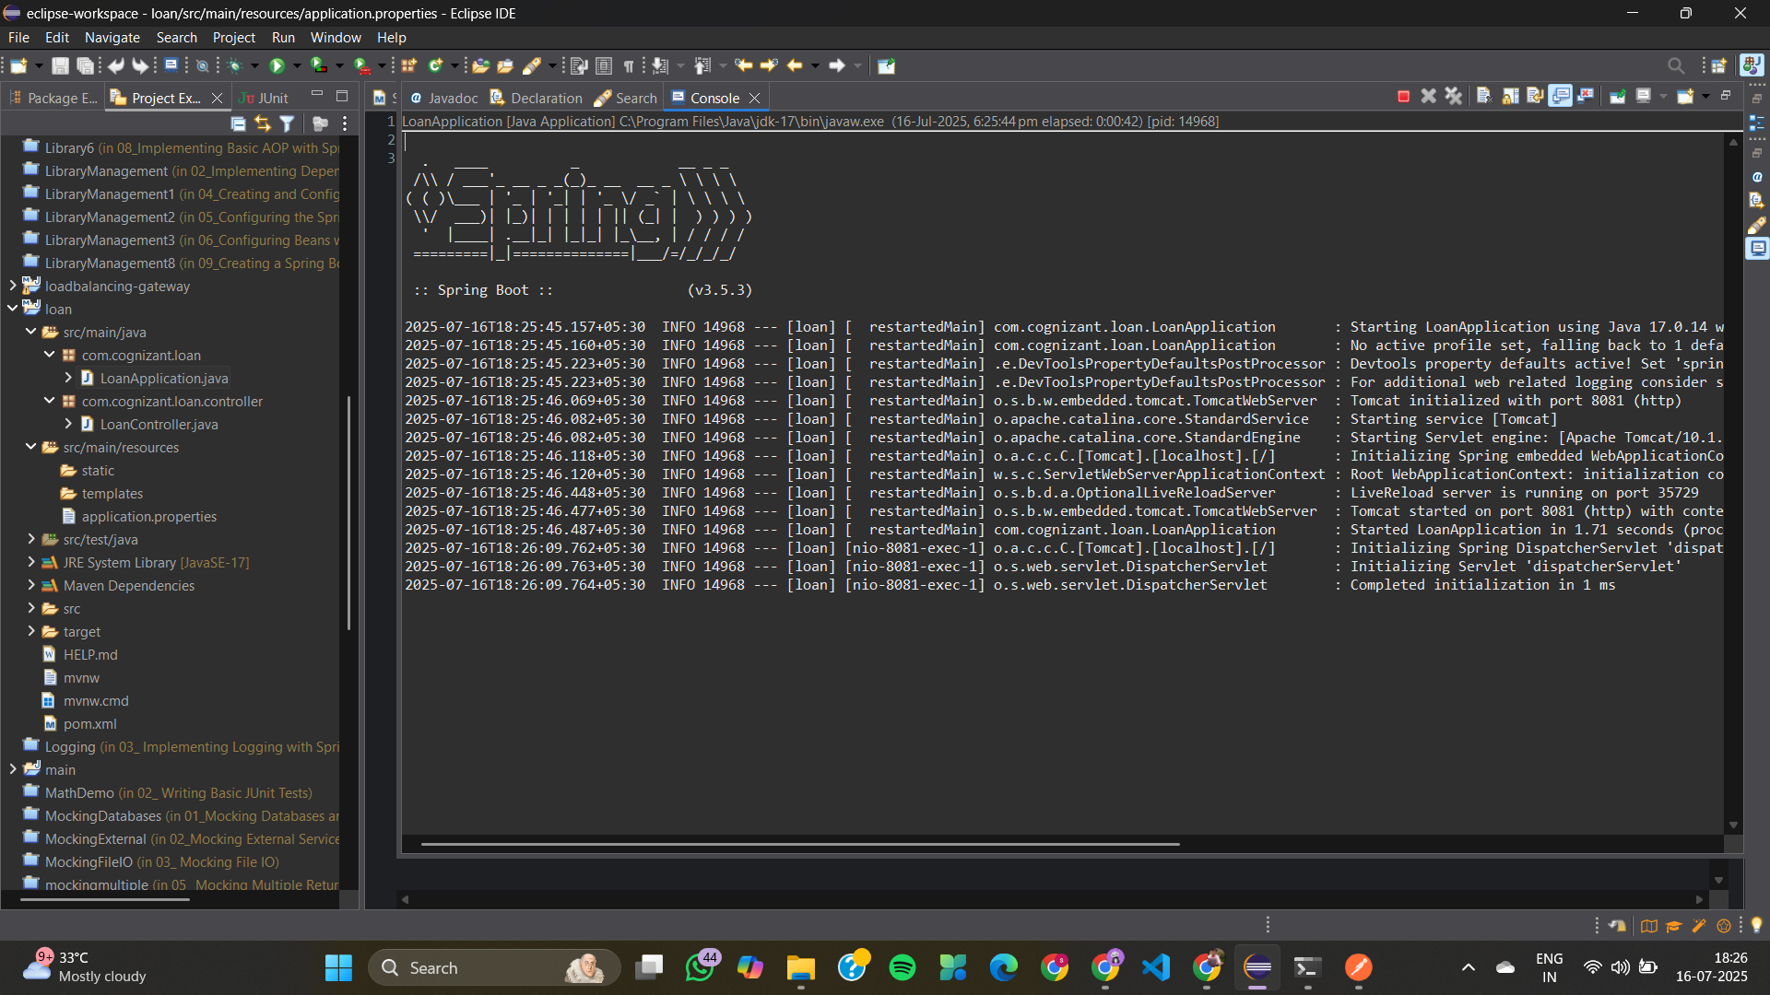
02_Eureka Discovery Server and register
Account
AccountController.java
package com.cognizant.account.controller;

import org.springframework.web.bind.annotation.GetMapping;
import org.springframework.web.bind.annotation.PathVariable;
import org.springframework.web.bind.annotation.RestController;

import java.util.Map;

@RestController
public class AccountController {

@GetMapping("/accounts/{number}")
public Map<String, Object> getAccountDetails(@PathVariable String number) {
return Map.of(
"number", number,
"type", "savings",
"balance", 234343
);
}
}
AccountApplication.java
package com.cognizant.account;

import org.springframework.boot.SpringApplication;
import org.springframework.boot.autoconfigure.SpringBootApplication;
import org.springframework.cloud.client.discovery.EnableDiscoveryClient;

@SpringBootApplication
@EnableDiscoveryClient
public class AccountApplication {
public static void main(String[] args) {
SpringApplication.run(AccountApplication.class, args);
}
}
application.properties
server.port=8080

spring.application.name=account-service

eureka.client.service-url.defaultZone=http://localhost:8761/eureka

AccountApplicationTests.java
package com.cognizant.account;

import org.junit.jupiter.api.Test;
import org.springframework.boot.test.context.SpringBootTest;

@SpringBootTest
class AccountApplicationTests {

@Test
void contextLoads() {
}

}
eureka-discovery-server
EurekaDiscoveryServerApplication.java
package com.cognizant.eurekadiscoveryserver;

import org.springframework.boot.SpringApplication;
import org.springframework.boot.autoconfigure.SpringBootApplication;
import org.springframework.cloud.netflix.eureka.server.EnableEurekaServer;

@SpringBootApplication
@EnableEurekaServer
public class EurekaDiscoveryServerApplication {
public static void main(String[] args) {
SpringApplication.run(EurekaDiscoveryServerApplication.class, args);
}
}
application.properties
server.port=8761

eureka.client.register-with-eureka=false
eureka.client.fetch-registry=false

logging.level.com.netflix.eureka=OFF
logging.level.com.netflix.discovery=OFF
EurekaDiscoveryServerApplicationTests.java
package com.cognizant.eureka_discovery_server;

import org.junit.jupiter.api.Test;
import org.springframework.boot.test.context.SpringBootTest;
import org.springframework.test.context.ActiveProfiles;

@SpringBootTest
@ActiveProfiles("test")
class EurekaDiscoveryServerApplicationTests {

@Test
void contextLoads() {
}
}
Loan
LoanController.java
package com.cognizant.loan.controller;

import org.springframework.web.bind.annotation.GetMapping;
import org.springframework.web.bind.annotation.PathVariable;
import org.springframework.web.bind.annotation.RestController;
import java.util.Map;
@RestController
public class LoanController {
@GetMapping("/loans/{number}")
public Map<String, Object> getLoanDetails(@PathVariable String number) {
return Map.of(
"number", number,
"type", "car",
"loan", 400000,
"emi", 3258,
"tenure", 18
);
}
}
LoanApplication.java
package com.cognizant.loan;
import org.springframework.boot.SpringApplication;
import org.springframework.boot.autoconfigure.SpringBootApplication;
import org.springframework.cloud.client.discovery.EnableDiscoveryClient;
@SpringBootApplication
@EnableDiscoveryClient
public class LoanApplication {
public static void main(String[] args) {
SpringApplication.run(LoanApplication.class, args);
}
}
application.properties
server.port=8081
spring.application.name=loan-service
eureka.client.service-url.defaultZone=http://localhost:8761/eureka
LoanApplicationTests.java
package com.cognizant.loan;
import org.junit.jupiter.api.Test;
import org.springframework.boot.test.context.SpringBootTest;
@SpringBootTest
class LoanApplicationTests {
@Test
void contextLoads() {

}
}
OUTPUT
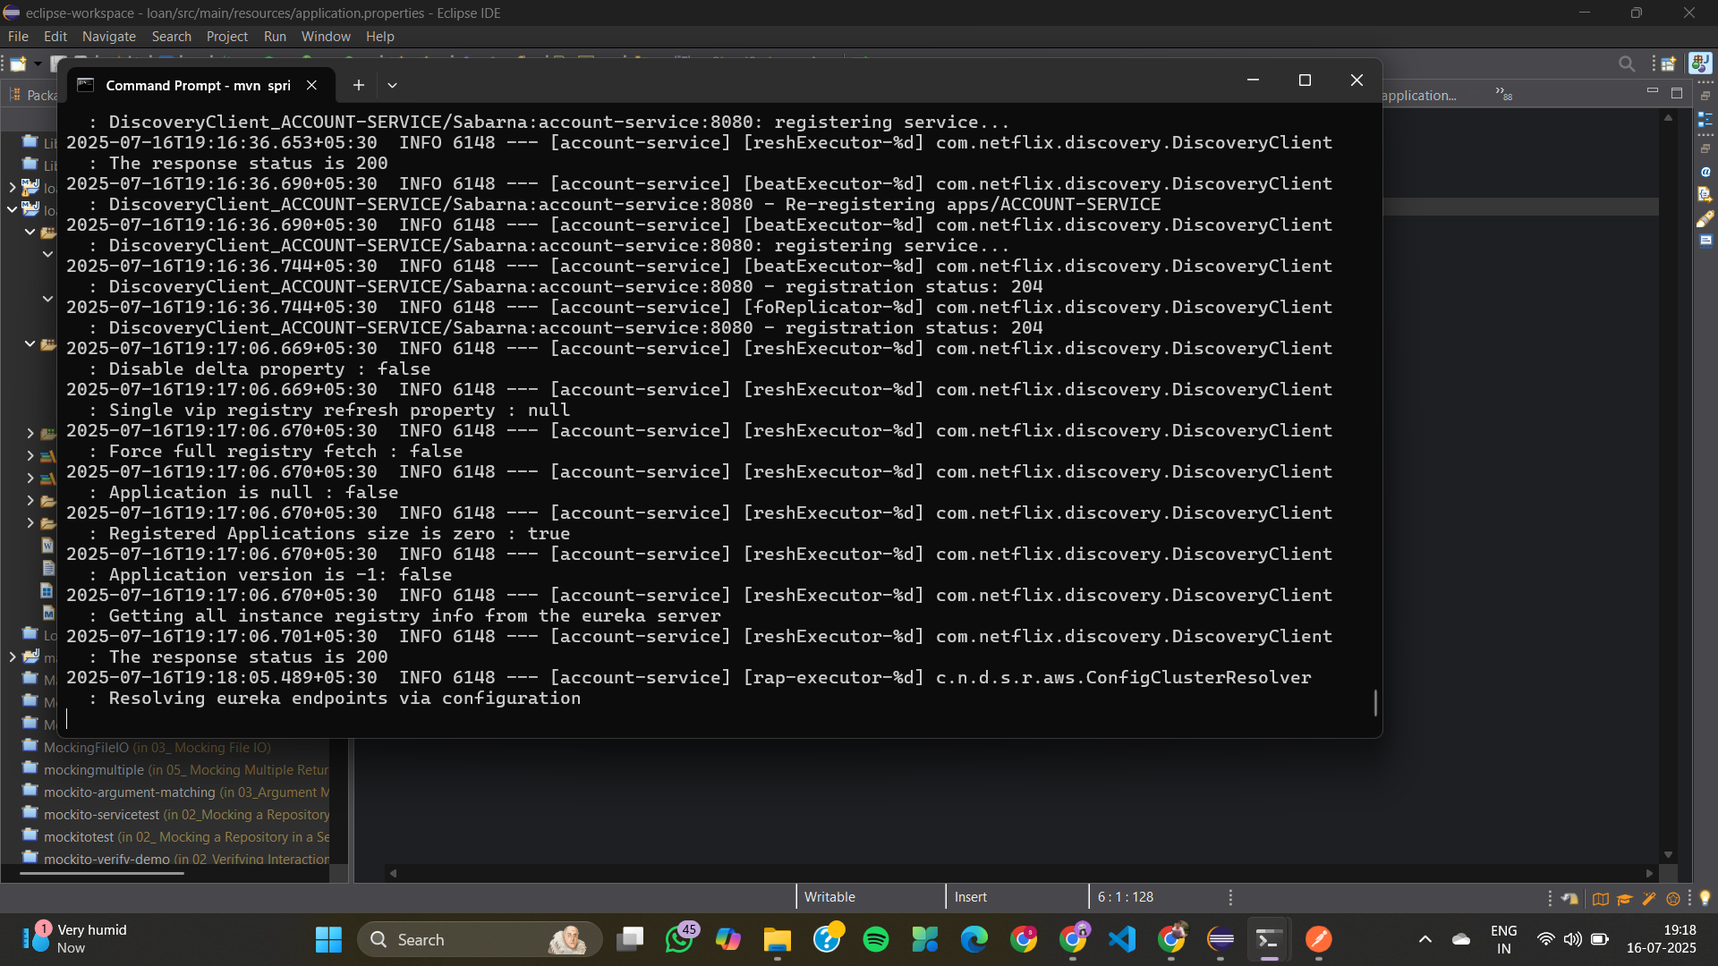
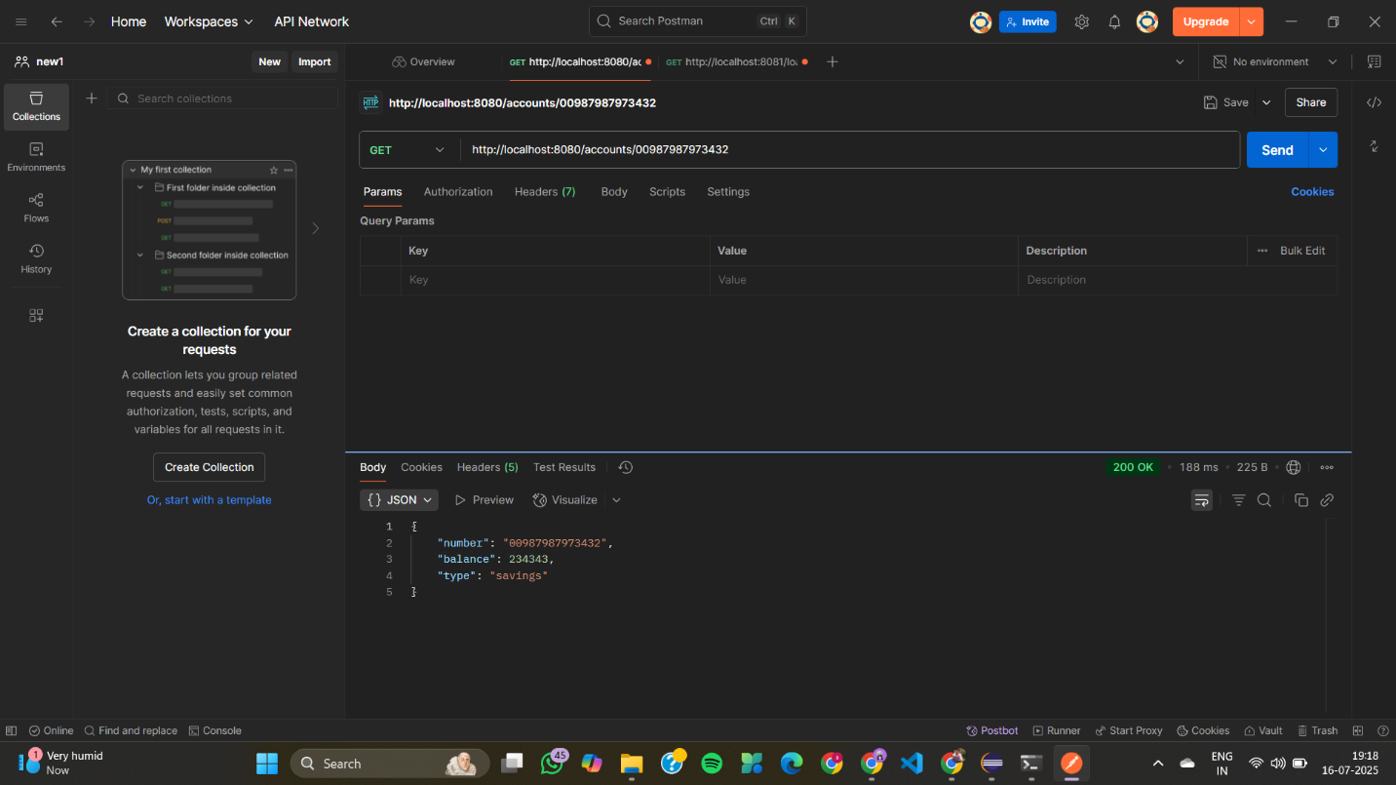
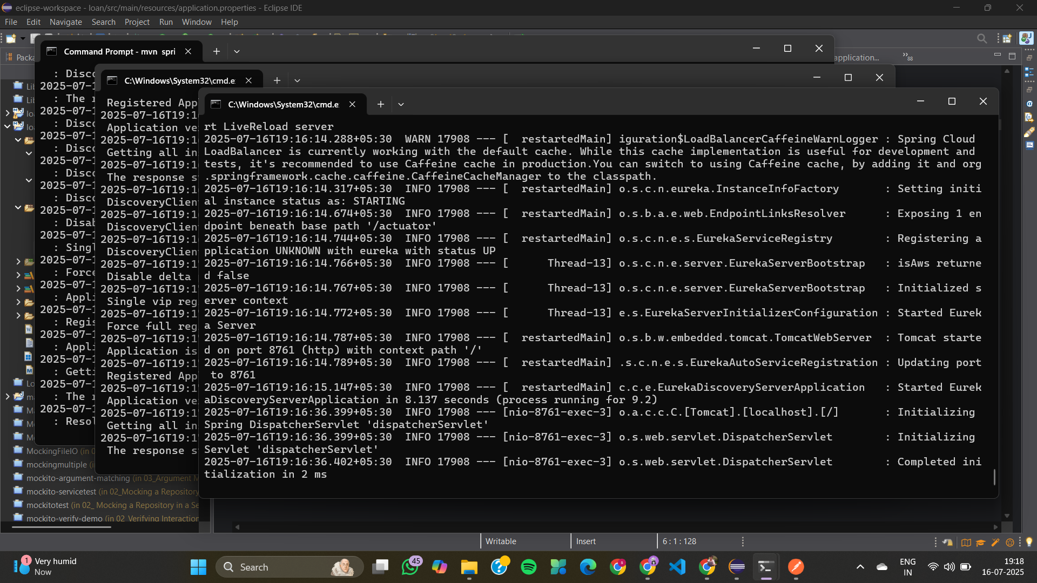
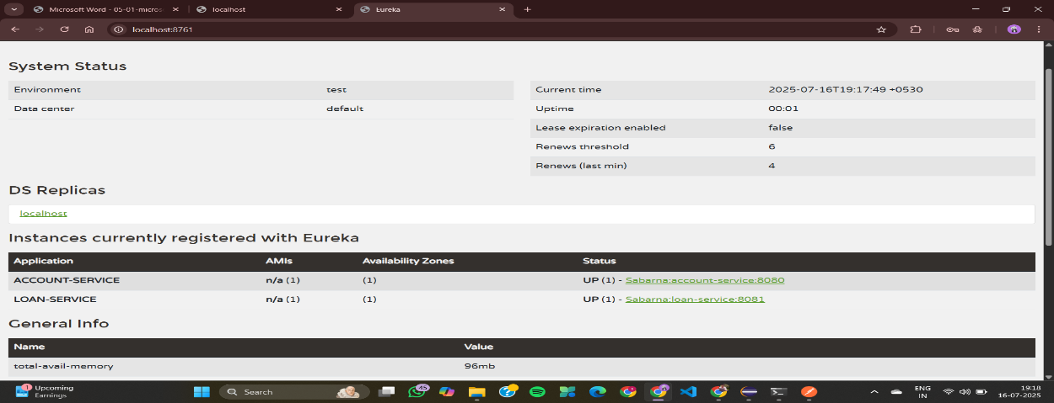
3. Create a Spring Cloud API Gateway and call one microservice thru the API gateway
api-gateways
RequestLoggingFilter.java
package com.cognizant.gateway.filter;

import org.slf4j.Logger;
import org.slf4j.LoggerFactory;
import org.springframework.cloud.gateway.filter.GlobalFilter;
import org.springframework.cloud.gateway.filter.GatewayFilterChain;
import org.springframework.core.Ordered;
import org.springframework.stereotype.Component;
import org.springframework.web.server.ServerWebExchange;
import reactor.core.publisher.Mono;

@Component
public class RequestLoggingFilter implements GlobalFilter, Ordered {

private static final Logger logger = LoggerFactory.getLogger(RequestLoggingFilter.class);

@Override
public Mono<Void> filter(ServerWebExchange exchange, GatewayFilterChain chain) {
logger.info("Request path: {}", exchange.getRequest().getPath());
return chain.filter(exchange);
}

@Override
public int getOrder() {
return -1;
}
}
ApiGatewayApplication.java
package com.cognizant.gateway;

import org.springframework.boot.SpringApplication;
import org.springframework.boot.autoconfigure.SpringBootApplication;
import org.springframework.cloud.client.discovery.EnableDiscoveryClient;

@SpringBootApplication
@EnableDiscoveryClient
public class ApiGatewayApplication {
public static void main(String[] args) {
SpringApplication.run(ApiGatewayApplication.class, args);
}
}
application.properties
server.port=9090
spring.application.name=api-gateway
eureka.client.service-url.defaultZone=http://localhost:8761/eureka

spring.cloud.gateway.routes[0].id=greet-service
spring.cloud.gateway.routes[0].uri=lb://greet-service
spring.cloud.gateway.routes[0].predicates[0]=Path=/greet/**
spring.cloud.gateway.routes[0].filters[0]=RewritePath=/greet/(?<segment>.*), /${segment}
ApiGatewaysApplicationTests.java
package com.cognizant.api_gateways;

import org.junit.jupiter.api.Test;
import org.springframework.boot.test.context.SpringBootTest;

@SpringBootTest
class ApiGatewaysApplicationTests {

@Test
void contextLoads() {
}
}
eureka-servers
EurekaServerApplication.java
package com.cognizant.eureka;

import org.springframework.boot.SpringApplication;
import org.springframework.boot.autoconfigure.SpringBootApplication;
import org.springframework.cloud.netflix.eureka.server.EnableEurekaServer;

@SpringBootApplication
@EnableEurekaServer
public class EurekaServerApplication {
public static void main(String[] args) {
SpringApplication.run(EurekaServerApplication.class, args);
}
}
application.properties
server.port=8761
spring.application.name=eureka-server
eureka.client.fetch-registry=false
eureka.client.register-with-eureka=false
EurekaServersApplicationTests.java
package com.cognizant.eureka_servers;

import org.junit.jupiter.api.Test;
import org.springframework.boot.test.context.SpringBootTest;

@SpringBootTest
class EurekaServersApplicationTests {

@Test
void contextLoads() {
}

}

greet-service
GreetController.java
package com.cognizant.greet.controller;

import org.springframework.web.bind.annotation.GetMapping;
import org.springframework.web.bind.annotation.RestController;

@RestController
public class GreetController {
@GetMapping("/greet")
public String sayHello() {
return "Hello World!!";
}
}
GreetServiceApplication.java
package com.cognizant.greet;

import org.springframework.boot.SpringApplication;
import org.springframework.boot.autoconfigure.SpringBootApplication;
import org.springframework.cloud.client.discovery.EnableDiscoveryClient;

@SpringBootApplication
@EnableDiscoveryClient
public class GreetServiceApplication {
public static void main(String[] args) {
SpringApplication.run(GreetServiceApplication.class, args);
}
}
application.properties
server.port=8080
spring.application.name=greet-service
eureka.client.service-url.defaultZone=http://localhost:8761/eureka
GreetServiceApplicationTests.java
package com.cognizant.greet_service;
import org.junit.jupiter.api.Test;
import org.springframework.boot.test.context.SpringBootTest;
@SpringBootTest
class GreetServiceApplicationTests {
@Test
void contextLoads() {
}
}
OUTPUT
